PDF Exporter ilogic

This rule speeds up the process of exporting a drawing as a PDF with automated checking for revision numbers and ECO Numbers.
When the rule is run, the following will occur:
- Validates file type; This rule will only run on a drawing. It will not run on part or assembly.
- Validate revision number; If there is a custom iproperty for 'Rev Number' it checks for a match with the standard 'Revsion Number’ iProperty. If there is amissmatch the user is alerted.
- Validate ECO number; Checks whether the ‘ECO Number’ iProperty has been set, if left blank the user is alerted.
- Prompts selection of a export location, then exports the drawing as PDF with suffix '_revNo' added.
Run the rule from the iLogic tab
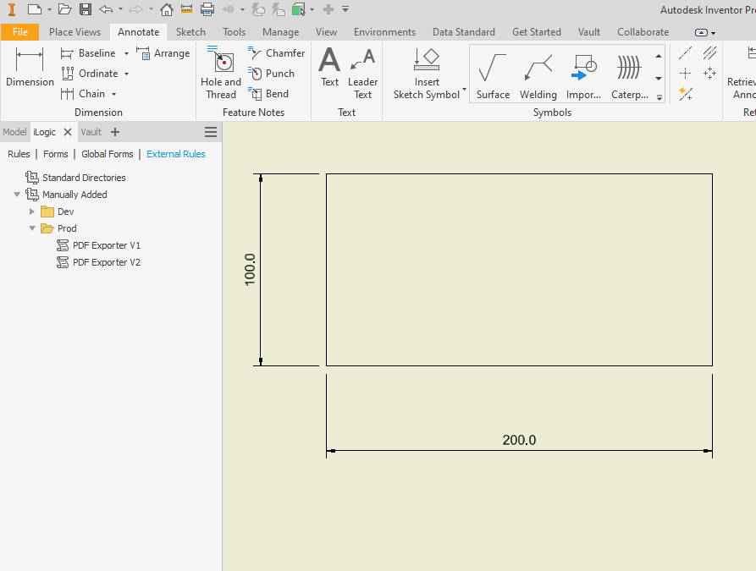

If revision and ECO numbers are set correctly, the folder picker prompt will appear:
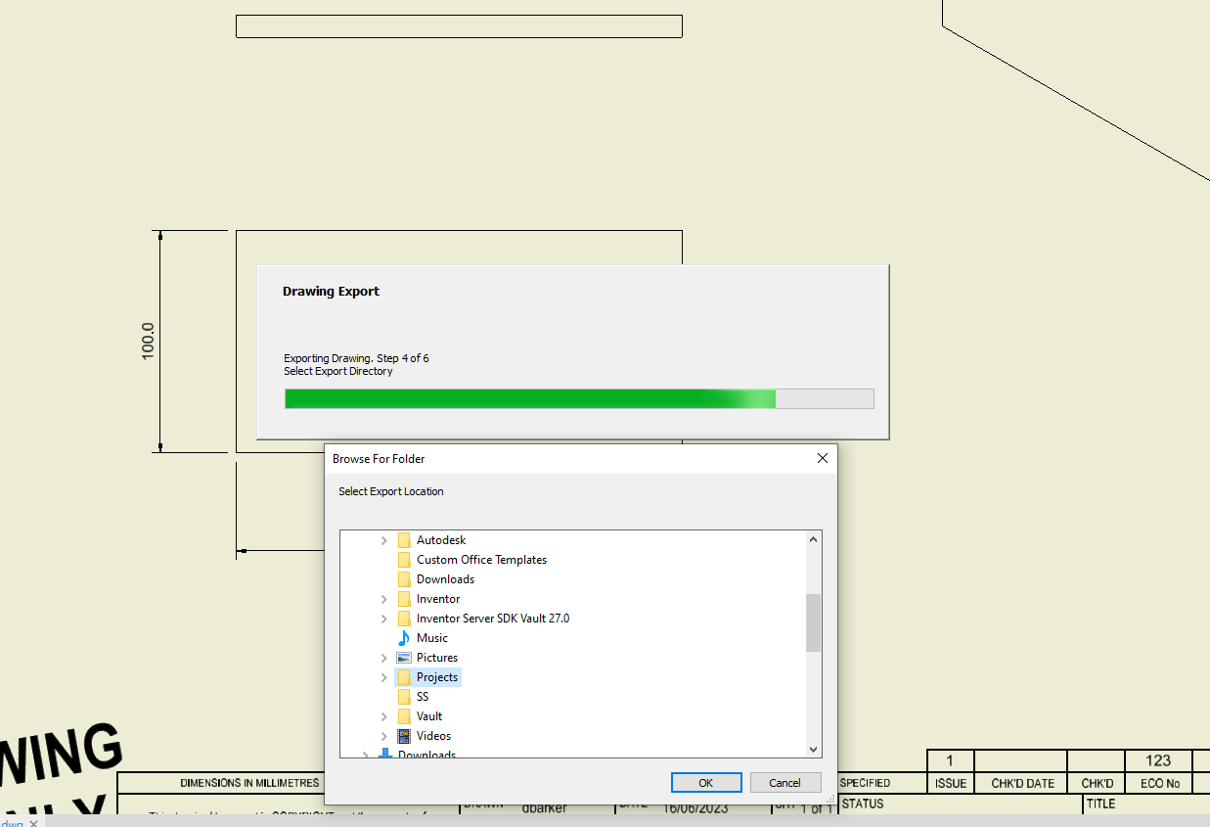
A message box will appear to alert the export is complete. It displays the file directory.
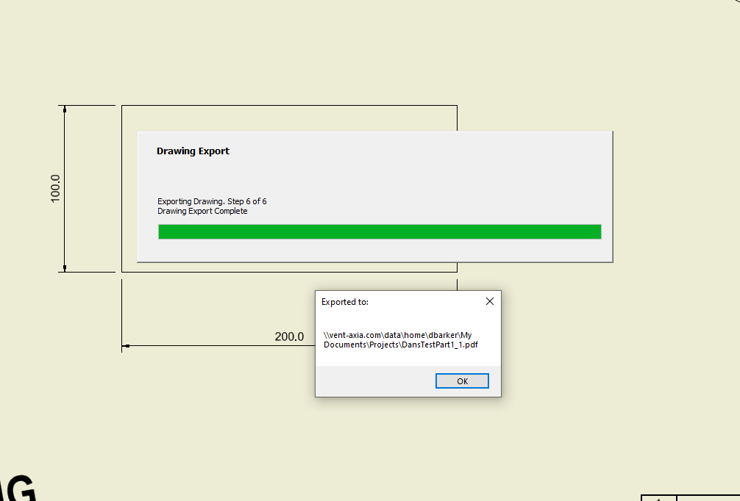
Error handling:
If the revision numbers do not match the following error box will appear. The user has the option to proceed anyway, or cancel the export.

